**Automotive Acquisitions**

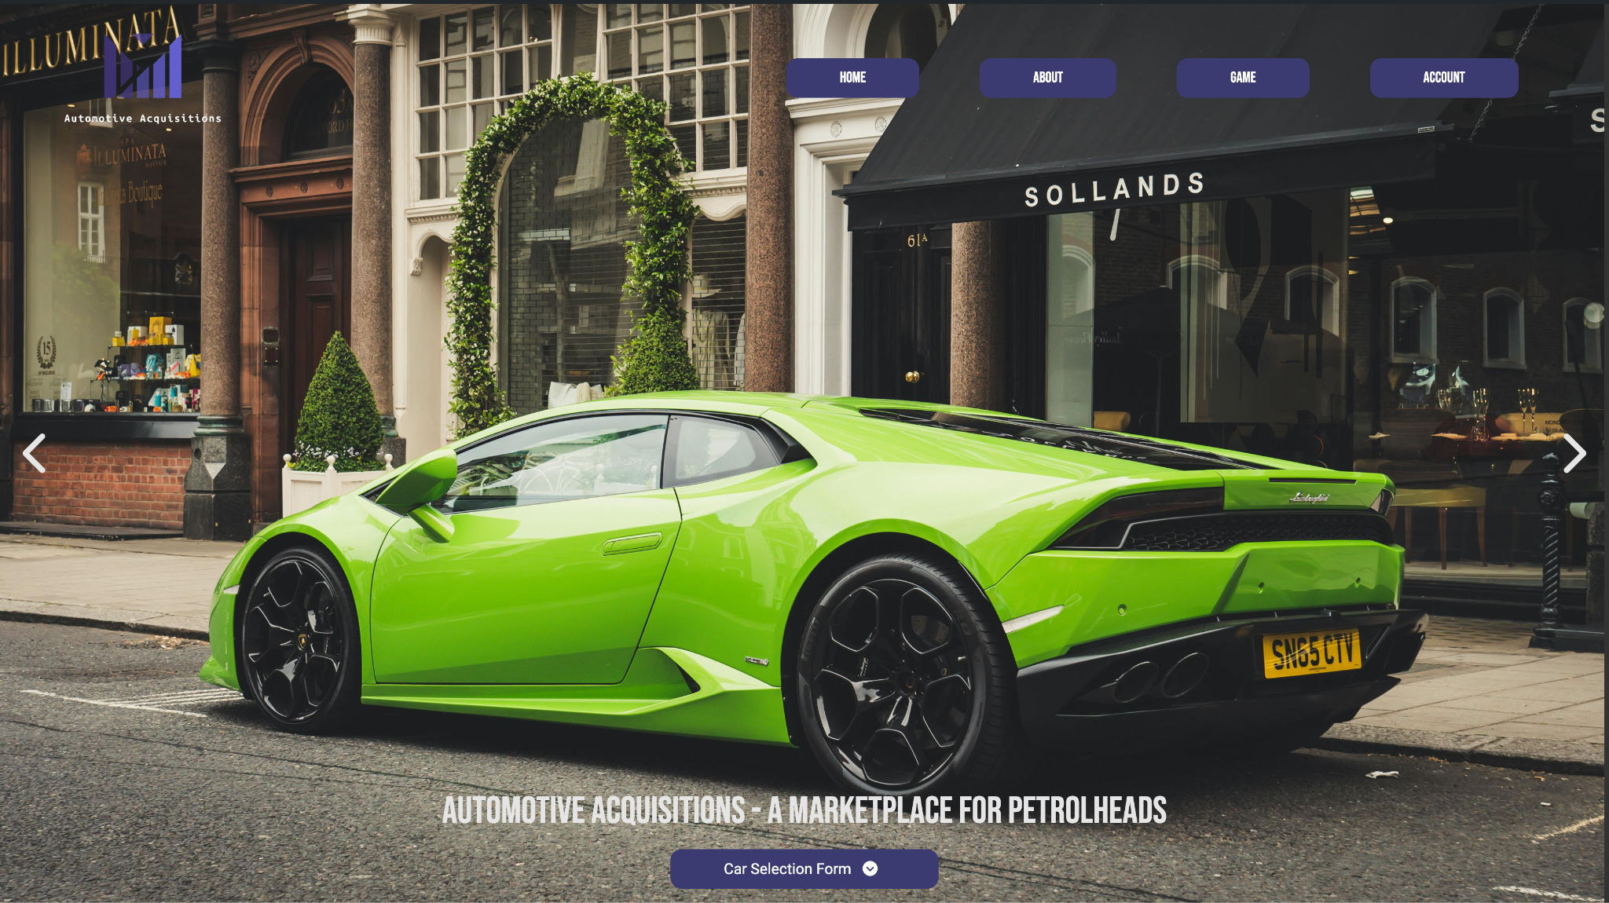

Website Domain: <https://d36twhq9evdbua.cloudfront.net>

Video Presentation Link: <https://studentncirl-my.sharepoint.com/personal/x23285508_student_ncirl_ie/_layouts/15/stream.aspx?id=%2Fpersonal%2Fx23285508%5Fstudent%5Fncirl%5Fie%2FDocuments%2Fautomotive%2Dacquisitions%2Emp4&referrer=StreamWebApp%2EWeb&referrerScenario=AddressBarCopied%2Eview>

Sean Welch x23285508

**Submitted to:** Hamilton Niculescu

**1. Executive Summary**

For this project, the company I have chosen to base the website development on is DoneDeal. More specifically though, the website will detail an hypothetical offshoot of DoneDeal specifically tailored to the used and second hand sale of luxury and bespoke cars; this subsidiary will be known as Automotive acquisitions. Automotive Acquisitions will be branded as a marketplace for those customers who are looking for the networking ability, as well as the reliability and security of donedeal, but without the flood of information of cars not suited to their niche requirements (DoneDeal, 2024).

In short, with this solution, our website, once fully developed, would be able to take significant load off the servers and database of donedeal. This would be due to the fact that information regarding any luxury or bespoke vehicle would be stored with Automotive Acquisitions thereby lowering computing resources for DonDeal and thereby operating costs too.

Moreover, the creation of Automotive Acquisitions will allow for increased customer satisfaction; by creating this subsidiary, customers will save significant time and money in their search for their niche vehicle demands. To end on, there are also other benefits to implementing Automotive Acquisitions as an offshoot of donedeal. For example, search engine optimization techniques will be easier to implement and optimise, thus leading to increased consumer traffic and end sales.

**2. Project Work**

Unfortunately, given that Automotive Acquisitions is in its start up phase, there was an issue with staff requirements and thus, this project was completed solely by myself. However, this did not stop the clear outlining of goals as well as separation on concerns in work methodology. For example, I developed a clear and distinct plan for how the website functionality would be divided amongst its various pages, as well as how the code would reflect this separation leading to clear, concise syntax and a maintainable codebase.

The project comprises four main pages (Homepage, About, Game, Account), each incorporating specific JavaScript features:

* Layout includes a Navbar, Main content, and Footer applicable across all pages.
* Homepage features an Image Carousel and Information Dialog, along with an Enquiry Form.
* The About page contains Sliders for detailed information on Automotive Acquisitions.
* Game page offers a unique feature allowing users to randomise car selection, which is then saved in local storage. This page also includes an Enquiry Form.
* Account page dynamically displays car data if available; otherwise, it shows a message indicating no data.
* More information on this can be found in the readme.md file of the projects source code

**3. Design Process**

Automotive Acquisitions follows a modern and sleek design, taking inspiration from many popular websites that follow a similar pattern of large hero images, such as Athletic Greens (<https://drinkag1.com/en-eu>), Zara (<https://www.zara.com/>) and Tesla (<https://www.tesla.com/>). Moreover, the simple colour palette of lilac, charcoal and whitesmoke colours reflects a minimalist and intuitive design.

Several sleek fonts such as Roboto, Bebas Nueu and Ojuju were used to give the text life and conform to our simple implementation. Moreover, CSS transitions and animations were used heavily amongst the various set pieces of the website in order to make the site responsive and feel alive and malleable.

Central to the design of the web application is the image carousel in the hero section of the main page. This carousel allows us to display all the cars we have on offer in a way that is accessible and easy to manage for the end user.

Moreover, with the implementation of javascript we are able to display secondary information about each vehicle to the user in a robust fashion. Wireframes were used extensively to model a primitive version of the site and ensure that the design concepts were followed extensively. These wireframes were implemented using figma and are robust in their nature (Figma, 2024).

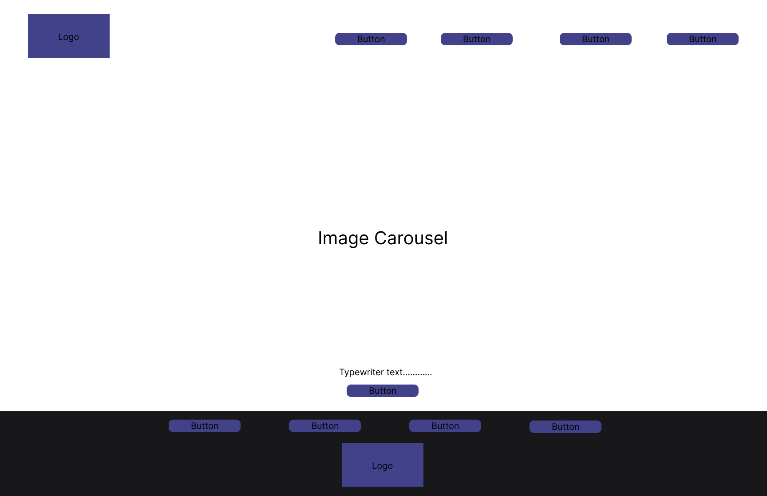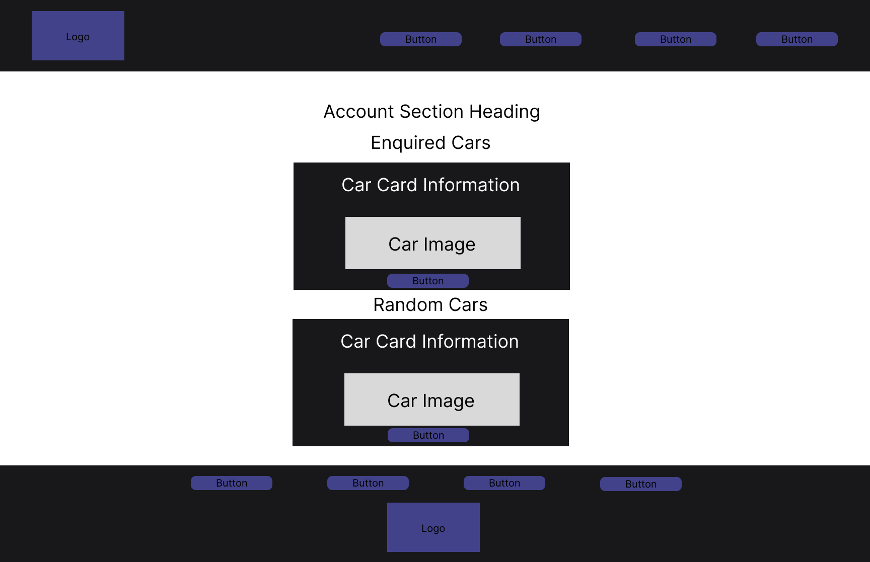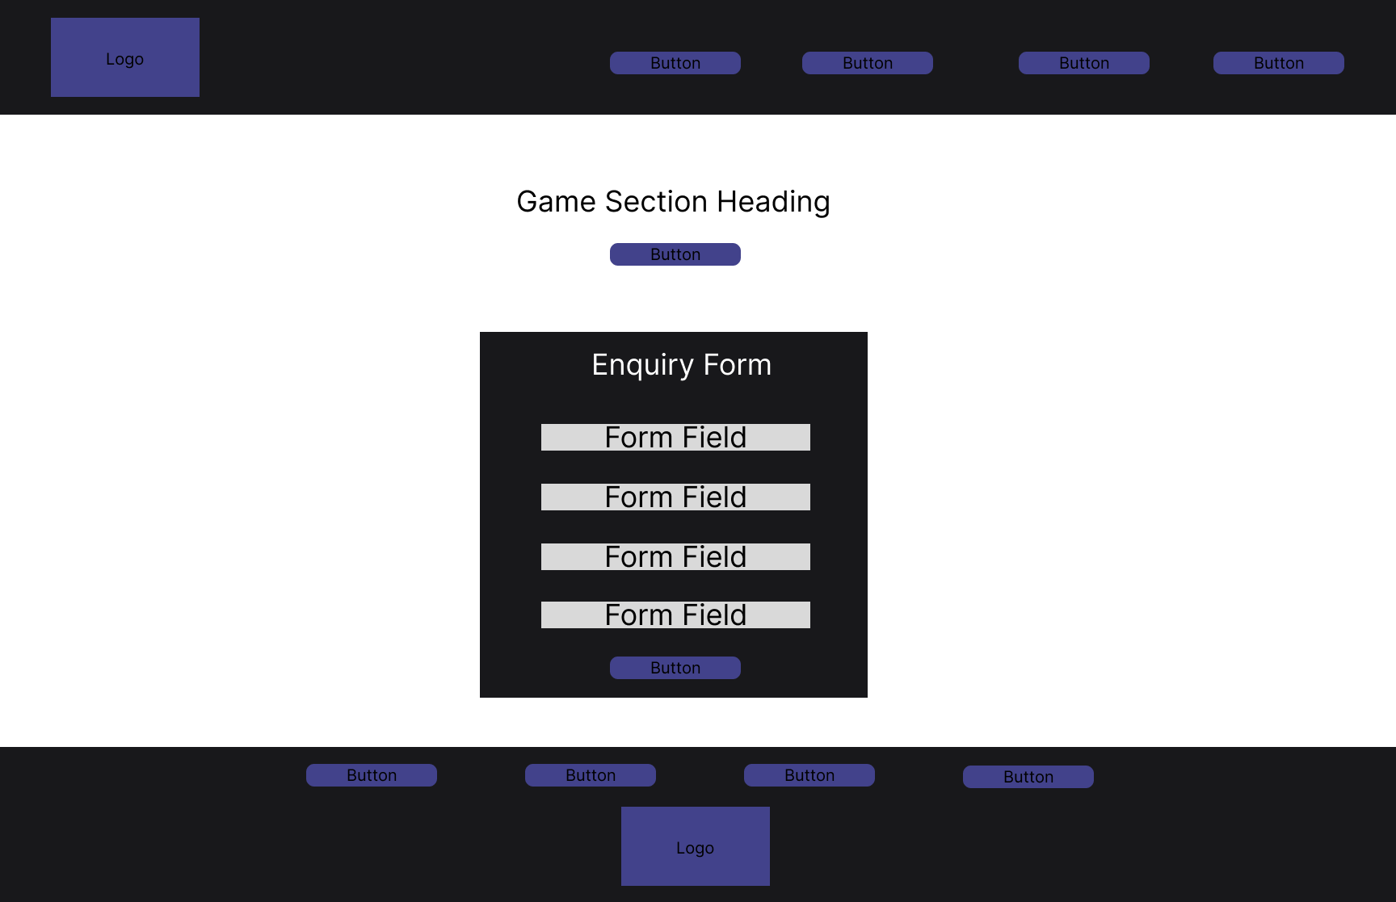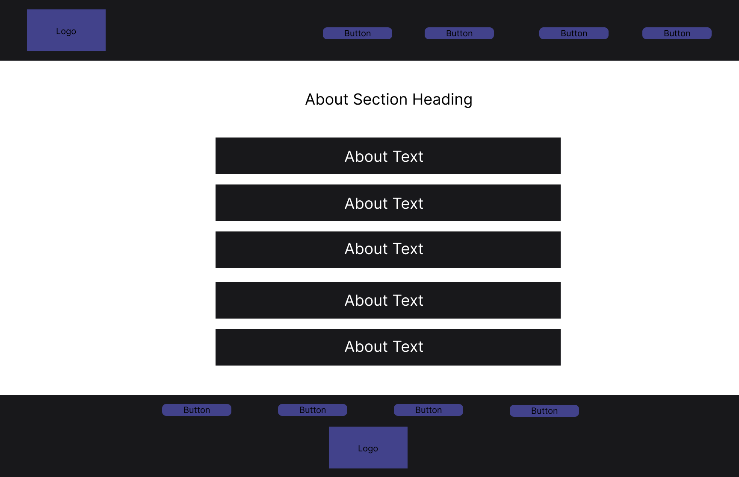

**4. Testing & Responsiveness**

Automotive Acquisitions is a modern, responsive and well managed website, it conforms to all the necessary aspects that a website should do in order to score high on google lighthouse metrics. For example, the website scored above 95 in all lighthouse metrics such as performance, accessibility, best practices and scored a perfect 100 on search engine optimization practices (Pol, 2021).

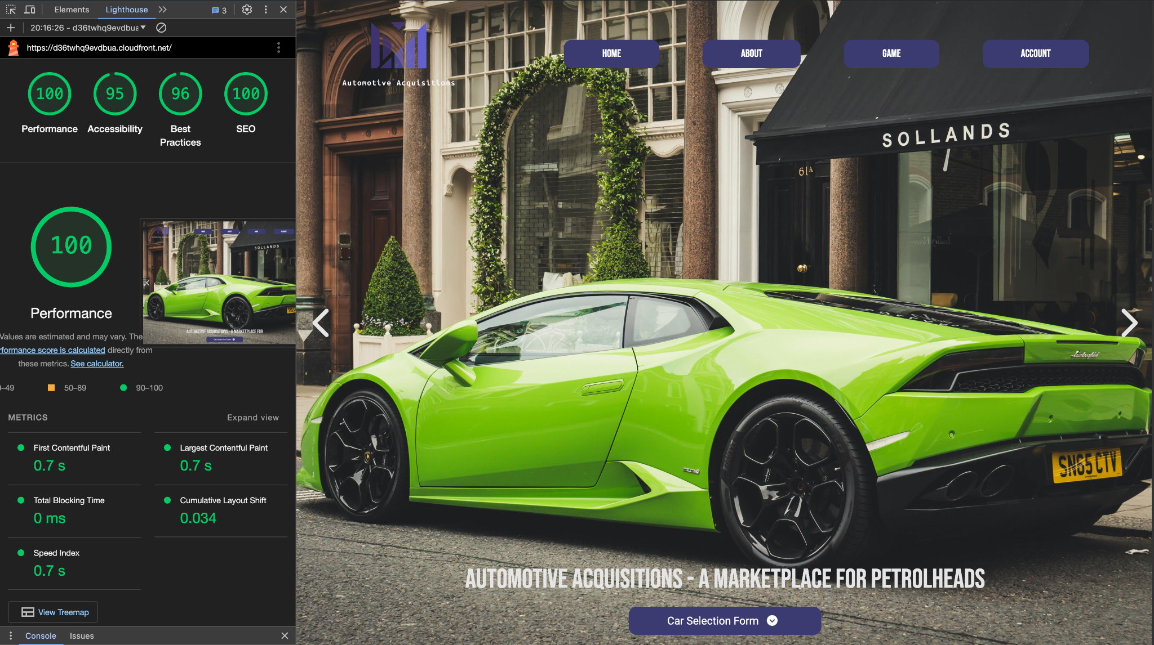

The website was made responsive using a combination of custom implemented javascript as well as CSS media queries in order to ensure mobile responsiveness, which is of course crucial for modern websites as most traffic comes from online.

Moreover, deployment is probably one of the most interesting aspects of Automotive acquisitions; it is deployed to an s3 storage bucket on amazon web services which is configured for static website hosting, thus allowing the html and javascript to be rendered (Arun, 2020). Furthermore, a cloudfront content delivery network is then deployed atop this storage bucket in order to increase performance, loading speed and accessibility for users across the globe (Afreen, 2020). Indeed deployment of new changes are automatic by sync and invalidation commands found within the makefile in the root directory.

**5. Conclusion**

In conclusion, the development of the project went well, the design and ideation stages of the product development made the coding implementation and deployment phases near trivial. Automotive Acquisitions is a modern, sleek and responsive website that achieves its goal of being a niche car market subsidiary of donedeal that allows for increased search engine optimisation and consumer satisfaction. Next time perhaps, I would use a lighter and more modern CSS framework such as Tailwind CSS to speed up the styling process (Tailwind, 2024). Also perhaps integrate a CI/CD pipeline with Github Actions such that any time a change was made to the master branch, our custom makefile scripts would be triggered thus updating the website across the globe (Github, 2024).

**Reference List**

Afreen, S. (2020) What is AWS CloudFront? Everything you need to know [updated], Simplilearn.com. Simplilearn. Available at: https://www.simplilearn.com/tutorials/aws-tutorial/aws-cloudfront (Accessed: April 20, 2024).

Arun, R. (2020) What is AWS S3: Overview, features & storage classes explained, Simplilearn.com. Simplilearn. Available at: https://www.simplilearn.com/tutorials/aws-tutorial/aws-s3 (Accessed: April 20, 2024).

DoneDeal (no date) DoneDeal.ie. Available at: https://www.donedeal.ie/ (Accessed: April 20, 2024).

GitHub Actions documentation (no date).

MDN Web Docs (no date) MDN Web Docs. Available at: https://developer.mozilla.org/en-US/ (Accessed: April 20, 2024).

Navy blue color palette (no date) Color-hex.com. Available at: https://www.color-hex.com/color-palette/88213 (Accessed: April 20, 2024).

OpenJS Foundation-openjsf.org (no date) JQuery API documentation, Jquery.com. Available at: https://api.jquery.com/ (Accessed: April 20, 2024).

Photopea (no date) Photopea.com. Available at: https://www.photopea.com/ (Accessed: April 20, 2024).

Pol, T. (2021) Google Lighthouse: What it is & how to use it, Semrush Blog. Semrush. Available at: https://www.semrush.com/blog/google-lighthouse/ (Accessed: April 20, 2024).

Rapidly build modern websites without ever leaving your HTML (no date) Tailwindcss.com. Available at: https://tailwindcss.com/ (Accessed: April 20, 2024).

Welch, S. (no date a) Client/src/styles at main · sean-david-welch/farmec-v2.

Welch, S. (no date b) development/static/js/carousel.js at main · sean-david-welch/Farmec-v1.

Welch, S. (no date c) development/static/js/typewriter.js at main · sean-david-welch/Farmec-v1.

Welch, S. (no date d) WebDesignFinal at main · sean-david-welch/college-labwork.

(No date a) Pexels.com. Available at: https://www.pexels.com/search/car/ (Accessed: April 20, 2024).

(No date b) Figma.com. Available at: https://www.figma.com/file/P7GQdiLBzmzh3bXWCRa6hV/Final-Wireframe?type=design&node-id=12-405&mode=design&t=Wqbj4U2ilw2QczHa-0 (Accessed: April 20, 2024).

(No date c) Amazon.com. Available at: https://aws.amazon.com/s3/ (Accessed: April 20, 2024).

—----------—----------—----------—----------—----------—----------—----------—----------—----------—----------—--------